LAKSHITA RAWAT

Roll No.- 16102

Section- A

OPERATING SYSTEM PRACTICAL

Q4. Write a program (using fork () and/or exec () commands) where parent and child execute:

i. same program, same code

ii. same program, different code.

iii. before terminating, the parent waits for the child to finish its task.

1. same program, same code

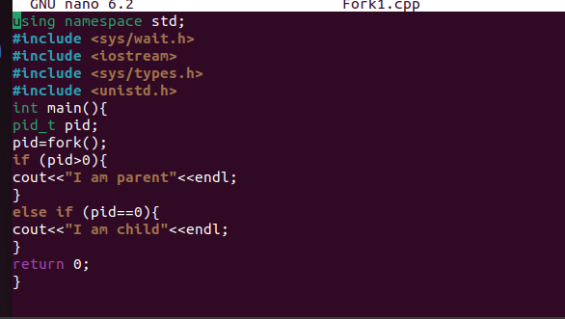**CODE:**

**OUTPUT:**

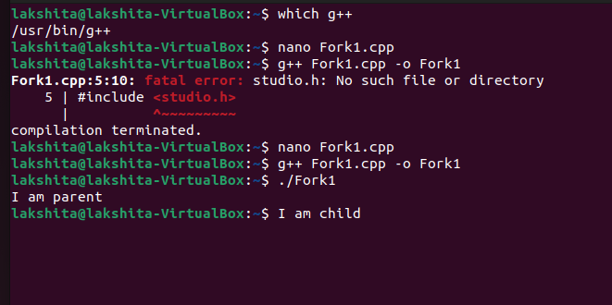

1. same program, different code

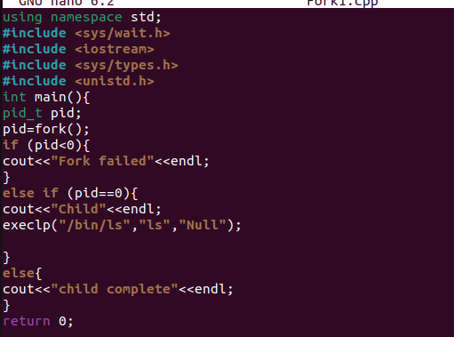**CODE:**

**OUTPUT:**

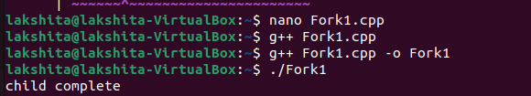

1. before terminating, the parent waits for the child to finish its task.

**CODE:**

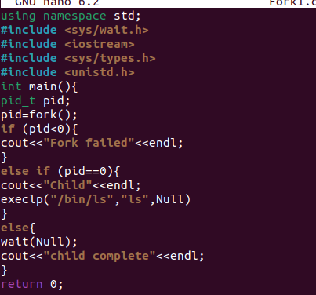

**OUTPUT:**

